**WEEK 1 : Design patterns and principles Handson**

**Exercise 1 – Singleton Pattern**

**Objective:**

Implement a Singleton design pattern to ensure that only one instance of a logging utility class is created and used throughout the application.

CODE :

Logger.java :

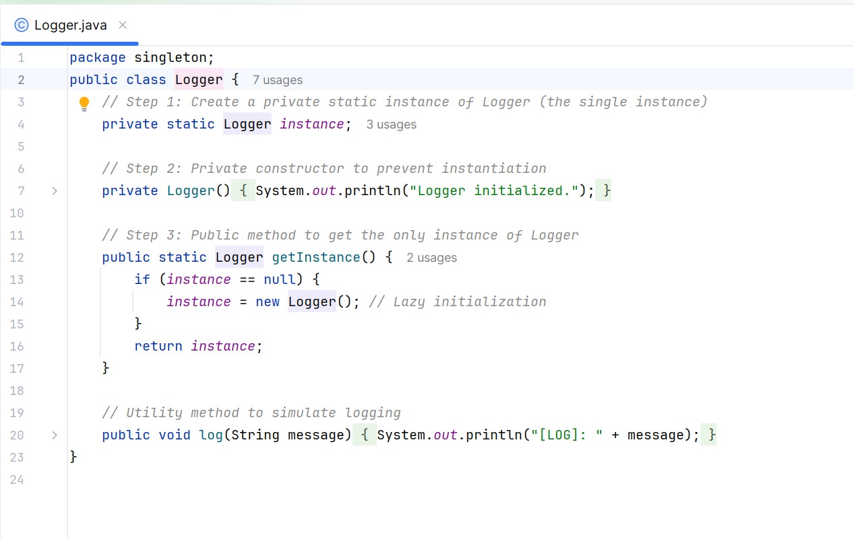

Main.java :

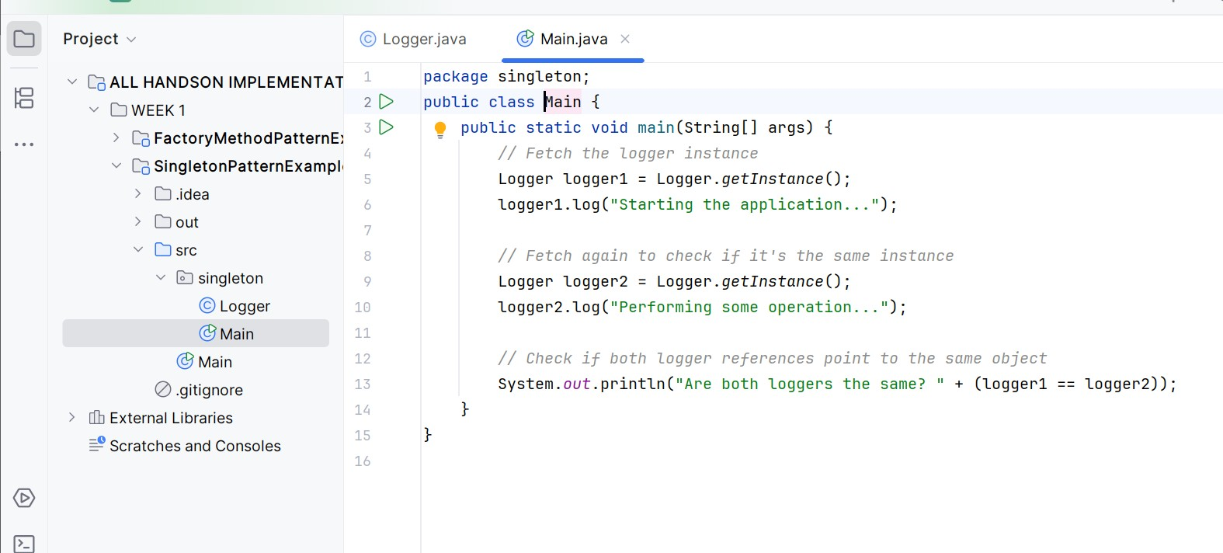

OUTPUT :

